Sri Lanka Institute of Information Technology



Assignment 1  
MLB_02.01_03

SLIIT students’ attitudes and preferences regarding time management

**English for Academic Purposes – IT1080**

B.Sc. (Hons) in Information Technology

Group Details

Group Number: MLB_02.01_03

Project Title: SLIIT students’ attitudes and preferences regarding time management

|  |  |  |  |
| --- | --- | --- | --- |
|  | **Student ID** | **Student Name** | **Email** |
| 1 | IT23166110 | D.D. HAPUTHANTHRI | it23166110@my.sliit.lk |
| 2 | IT23156074 | R.M.H.I. RATHNAYAKE | it23156074@my.sliit.lk |
| 3 | IT23160866 | U.P.H.S ABEYWICKRAMA | it23160866@my.sliit.lk |
| 4 | IT23164376 | W.M.T.P.K WANASINGHE | it23164376@my.sliit.lk |
| 5 | IT23163218 | M.H.S. PERERA | it23163218@my.sliit.lk |

Terms of References

A report submitted in fulfillment of the requirement for the module IT1080, Sri Lanka Institute of Information Technology.

Acknowledgment

We would like to convey our heartfelt appreciation for the unwavering support we received during our research on ‘SLIIT students’ attitudes towards time management.’ Our esteemed lecturers provided invaluable guidance and an opportunity that we deeply appreciate. We also extend our sincere thanks to the SLIIT staff, survey participants, researchers, and team members who made significant contributions. It is through their collective effort and support that we completed this endeavor.

Table of Contents

1. Abstract 5

2. Introduction 6

3. Methodology 7

4. Data analysis and discussion 8

4.1 Distribution of SLIIT students’ ideas about Time Management 8

4.1.1 Time Management based on their age groups. 8

4.1.2 Time Management, grouped by different Faculties and Schools. 9

4.1.3 Time Management divided into academic years. 10

5. Planning and Organization 12

5.1 How often do you plan your daily tasks. 12

5.2 Do you establish deadlines for your tasks. 13

5.3 Do you prioritize tasks based on their importance. 14

# Abstract

The survey looked at how students at SLIIT manage their time. The findings indicated a wide range of methods for daily task planning, with some students adopting time management tools and applications and others opting for traditional strategies or none.  
  
Students frequently study outside of class, demonstrating their commitment to academics. However, how they set deadlines varied: some prioritized operations based on their importance, while others needed help to achieve a balance. This regularly resulted in task delays, highlighting a common challenge in workload management.  
  
Interestingly, while many students recognized the importance of prioritization, multitasking was frequent. This mismatch reflects an imbalance between perceived and real-time management techniques.

Students frequently sought help and rearranged their schedules to accommodate unexpected occurrences. Despite hurdles, students acknowledged the need to take intentional breaks in their schedules and prioritize self-care for productivity.

Respondents' trust in their time management abilities varied, reflecting their diverse experiences and strategies. The survey included a total of 100 participants, and the results give a thorough overview of SLIIT students' time management methods. This large sample size legitimizes the survey findings, allowing for stronger conclusions and implications for future support and assistance activities.

In conclusion, the survey indicates the complex interaction of individual habits, tools, and difficulties in effective time management among SLIIT students, underlining the importance of focused interventions and help in improving their skills and academic achievement.

# Introduction

The survey indicates that SLIIT students apply diverse time management approaches, which exert a critical influence on their academic and personal aspects. The differences in the strategies employed by students to outline their time indicated above are evidenced by the variety of methods implemented by all the participants. Whereas some may employ digital systems, including applications and programs, others opt for more traditional ways or even rely only on memory and intuition.

Another notable finding in the survey was the relatively high level of motivation among SLIIT students in pursuing their academic goals. Many students reported investing elusive amounts of time studying and doing assignments outside of class, reflecting their dedication to academic success. However, the individual approach students have to their deadlines differed greatly even while being aware of the importance of prioritization. While some had a clear understanding of the concept and ability to plan, others had trouble balancing multiple responsibilities causing them to miss deadlines frequently. This is like the seemingly established concept of priority and distribution of tasks. Most of the students seem adept at juggling, but the connection is lost, meaning they know these techniques but somehow fail to implement them.

In addition, although several students have reported the importance of meeting deadlines, they still faced difficulties when it came to doing so, thus indicating a clear need for more support in this aspect. While struggling, SLIIT students have used their creative thinking to ask for help and make changes to their schedules when they must deal with an unpredictable situation. This outcome indicates that the time management approach they take is comprehensive, where students regularly engage with adaptability and resilience to be able to manage campus, work, and personal responsibilities. Finally, the survey findings suggest that students increasingly acknowledge the relationship between their well-being and productivity. Many students mentioned the importance of taking regular breaks and prioritizing well-being to maintain the highest-performance levels.

# Methodology

The main source of information for this project is SLIIT students’ attitudes and preferences regarding time management, which we collected through a Google form. The form consisted of 20 questions aimed at understanding students’ time management mechanisms and the strategies they use. We received responses from 100 students at SLIIT University. Participants completed time management questionnaires with multiple-choice answers and rated statements on a scale of 1 to 5. Additionally, they provided written comments on the survey. Throughout data processing, we ensured participant anonymity.

For our report, we analyzed all student responses using descriptive statistics. We primarily used pie charts to display percentage breakdowns of responses within each subject and column charts for straightforward comparisons and patterns. These visualizations offer insightful analysis of the information gathered.

To supplement our findings, we conducted internet research related to our topic. Each group member was assigned specific areas of the report to research. By carefully examining the answers provided by our chosen sample, we compiled the necessary information for our final report.

Overall, our research sheds light on SLIIT students’ approaches to time management, and educators and administrators can use these insights to tailor interventions and support programs to enhance students’ academic performance and overall well-being.

# Data analysis and discussion

## Distribution of SLIIT students’ ideas about Time Management

### Time Management based on their age groups.

Forms response chart. Question title: 1) What is your age group ?
. Number of responses: 100 responses.

Based on SLIIT students’ age groups, demographics in time management are represented in the above pie chart.

We discovered that the ages of SLIIT students varied between groups when it came to their attitudes and preferences for time management. Most responders (57%) were between the ages of 21 and 23. This age group often comprises young adults transitioning into higher education and the workforce, thus their perspectives on time management are especially pertinent. Furthermore, 27% of respondents were between the ages of 18 and 20, representing a sizable proportion of the student population. Meanwhile, 13% were between the ages of 24 and 26, indicating a significantly older cohort with perhaps distinct approaches to time management. A lower fraction, 2%, were between the ages of 27 and 30, with only 1% being 30 or older.

These data emphasize the broad age distribution of SLIIT students surveyed, indicating that time management techniques may change across the phases of early adulthood.

### Time Management, grouped by different Faculties and Schools.

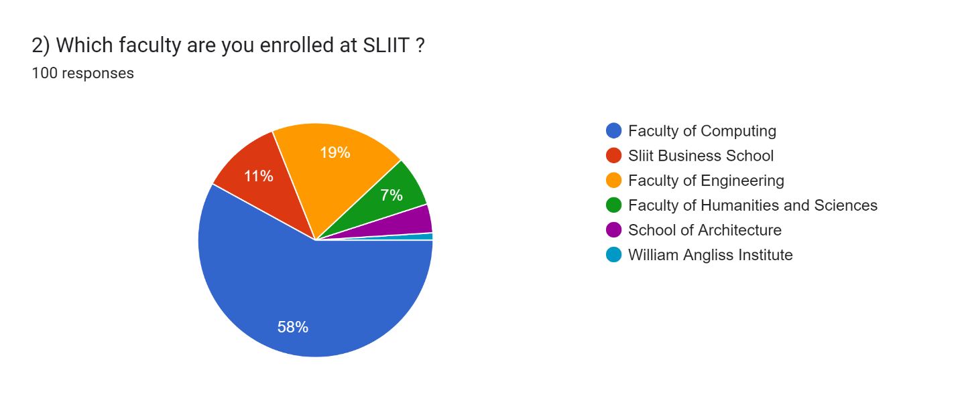

The above pie chart represents the distribution of students' demographics in Time management at SLIIT, grouped by different faculties and schools.

The Faculty of Computing has the biggest percentage of students across all faculties and schools, accounting for 58% of total responses. This indicates a considerable interest in and active participation in time management among the computer professors at SLIIT.  
  
Following closely after is the Faculty of Engineering, with 19% of students taking part in the online time management survey. This demonstrates a strong emphasis on time management at the Faculty of Engineering.  
  
In contrast, students from the SLIIT Business School and the Faculty of Humanities and Sciences accounted for 11% and 7% of the surveyed students, respectively. This implies that students in the SLIIT Business School are more interested in time management than those in the Faculty of Humanities and Sciences.

According to current survey statistics, the School of Architecture and William Angliss Institute have the lowest representation among all faculties and schools, with only 4% and 1% of respondents, respectively.   
  
Overall, the pie chart presents an overview of students' perspectives on time management across faculties and institutions. It demonstrates that students in the Faculty of Computing are more engaged in time management than students from other faculties and schools. The Faculty of Engineering has the second-highest proportion, followed by the SLIIT Business School and the Faculty of Humanities and Sciences. In contrast, the School of Architecture and the William Angliss Institute had the lowest participation in the survey.

### Time Management divided into academic years.

Forms response chart. Question title: 4) What is your current year of study at SLIIT ?
. Number of responses: 100 responses.

The above pie chart illustrates the distribution of students’ demographics regarding Time management at SLIIT, categorized by the academic year of the students.

According to the survey results, the majority of participating students (61% of total respondents) were in their first year. This suggests that a large proportion of students who took the online survey and expressed an interest in time management were first-year students.   
  
According to the data obtained from SLIIT students, 31% of respondents were in their second year. This shows that second-year students are less engaged in time management than their first-year colleagues.   
  
Additionally, 8% of participants who supplied demographic information stated that they were in their third year. This research indicates that students in their third year are even less engaged with time management than those in their first and second years.

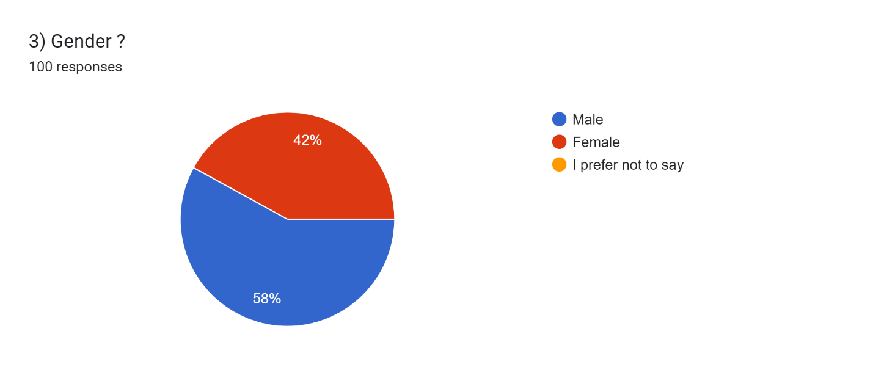In conclusion, our survey findings give insight into SLIIT students' participation in time management during the academic year. First-year students demonstrated the highest degree of involvement, followed by second-year students, while third-year students exhibited the lowest level of engagement.   
  
  
4.1.4 Time Management, categorized by gender.

The distribution of SLIIT students' demographics about time management, broken down by gender, is shown in the pie chart above. With 58% of all replies, male students made up the majority of responders, suggesting that male SLIIT students are quite interested in time management. On the other hand, 42% of participants were female, indicating that female students participate in time management activities at a considerably lower rate. Studies show that students' gender has a significant and variable impact on their time management and study habits. Studies indicate that women do better in both short- and long-term planning, even if males believe they are good time managers based on their self-reports. Interestingly, there's a noticeable difference in how well-versed in time management women are compared to males.

Gender, however, does not appear to have much of an effect on time management practices when it comes to academic accomplishment. These findings show the intricate relationships between gender and time management and underline the need for specific approaches in educational settings. They also highlight the need to encourage balanced time management practices among SLIIT students, whether male or female.

# Planning and Organization

## How often do you plan your daily tasks.

Forms response chart. Question title: 5) How often do you plan your daily tasks ?
. Number of responses: 100 responses.

Effective daily task planning is essential for optimizing productivity and achieving personal and professional goals. This report examines the habits and strategies of individuals in planning their daily tasks, aiming to understand the frequency of planning, the methods used, and the impact on overall productivity.

The following chart presents the results of a survey inquiring about the frequency of daily task planning among 100 students in SLIIT. A quarter of the students, 25%, reported that they often plan their daily tasks, while 22% students stated they rarely do. Conversely, 45% of the students mentioned that they plan their daily tasks sometimes, and 8% reported that they always plan their daily tasks.

Furthermore, the chart reveals that a significant number of students, 45%, plan their daily tasks sometimes, indicating a moderate level of time management skills. This suggests that these students may have some level of organization and structure in their daily routines but may not have fully optimized their daily task planning.

## Forms response chart. Question title: 8) Do you establish deadlines for your tasks? . Number of responses: 100 responses. 5.2 Do you establish deadlines for your tasks.

Establishing deadlines for tasks is a critical component of time management and productivity. Deadlines serve as a clear and specific target for completing a task, providing a sense of direction and focus for the individual or team responsible for the task. By setting deadlines, individuals can prioritize their tasks, allocate their time and resources effectively, and avoid procrastination.

The following chart illustrates the frequency of establishing deadlines for tasks among the 100 students in SLIIT. A majority of the students, 55%, reported that they always establish their tasks, while 20% of the students stated they rarely do. Also, 7% of the students often establish deadlines for their tasks, while 6% always do. However, 12% of students never establish deadlines for their tasks.

According to the above pie chart, it is evident that a significant portion of the student population at SLIIT recognizes the importance of establishing deadlines for tasks. With 55% of students reporting that they always set deadlines, there is a strong inclination towards prioritizing and managing time effectively. However, it is concerning that 12% of students never establish deadlines, highlighting a potential area for improvement in time management practices among the student body. Establishing deadlines not only enhances productivity but also fosters a sense of accountability and discipline in academic and professional endeavors.

## Forms response chart. Question title: 10)  Do you prioritize tasks based on their importance? . Number of responses: 98 responses. Do you prioritize tasks based on their importance.

Prioritizing tasks based on importance means assigning a level of urgency and significance to each task we must complete. This helps us to decide which tasks to do first, which ones to delegate or defer, and which ones to eliminate or reduce. By doing so, we can optimize our time, energy, and resources, and achieve better results and outcomes.

Prioritizing tasks based on importance has many benefits for our time management, such as helping increase productivity and efficiency, improving decision-making and problem-solving skills, reducing stress and anxiety, and enhancing motivation and engagement.

In the SLIIT time management survey, students' methods of prioritizing work based on priority differed. According to the pie chart, the majority of participants (40.8%) said they sometimes prioritize their activities based on priority. This shows that a sizable proportion of students occasionally think about the value of their tasks while organizing their workload.   
  
Furthermore, 20.4% of participants reported often prioritizing activities based on priority, showing a proactive approach to workload management, and ensuring that critical tasks receive appropriate attention. However, 18.4% of respondents said they rarely prioritize activities based on priority, indicating a possible area for growth in their time management abilities.

Also, 16.3% of participants reported prioritizing activities according to significance, indicating a persistent attempt to focus on the most important things first. However, 4.1% of respondents acknowledged to never prioritize activities based on priority, underscoring the need for assistance in creating efficient prioritization methods.

* 1. **How often do you postpone tasks.**

Forms response chart. Question title: 11) How often do you postpone tasks?
. Number of responses: 100 responses.

Students' procrastination is impacted by a variety of variables, including low motivation, a sense of time pressure, ineffective time management, fear of failing, an excessive workload, a lack of confidence, distractions, and difficulty focusing. It takes self-awareness, self-control, efficient time management techniques, and dealing with underlying problems like motivation and fear to overcome.   
  
Students' propensity to put off work differed according to the SLIIT time management survey. 47% of respondents said they occasionally put off doing tasks, which lowers stress and productivity. 25% of them seldom delay work, and there was reduced procrastination. Nonetheless, 18% often postponed tasks, indicating a need for better time management. While 4% of respondents always did, suggesting possible problems with task management, 6% of respondents never did so, demonstrating proactive attitudes.

Overall, the pie chart shows that SLIIT students use a variety of strategies to put off tasks, from rare to regular procrastination. Recognizing these trends can aid in the creation of specialized treatments that enhance academic achievement and time management abilities.

**5 Utilization of Tools and Techniques**

**5.1 Do you utilize time management tools or apps.**

Forms response chart. Question title: 6) Do you utilize time management tools or apps ?
. Number of responses: 100 responses.

In the SLIIT time management survey, participants used different time management tools or applications. According to the pie chart, 62% of respondents said they sometimes employ time management tools or applications. This shows that a considerable number of students occasionally use technology to help them organize their schedules and responsibilities.   
  
Furthermore, 25% of participants reported rarely utilizing time management tools or applications, indicating a lower frequency of use in this group. Only 3% reported often utilizing such tools, while 4% claimed to always use them. Overall, the pie chart shows the various usage patterns of time management software among SLIIT students, ranging from occasional to constant use.

**5.2 Do you allocate specific time slots for different activities.**

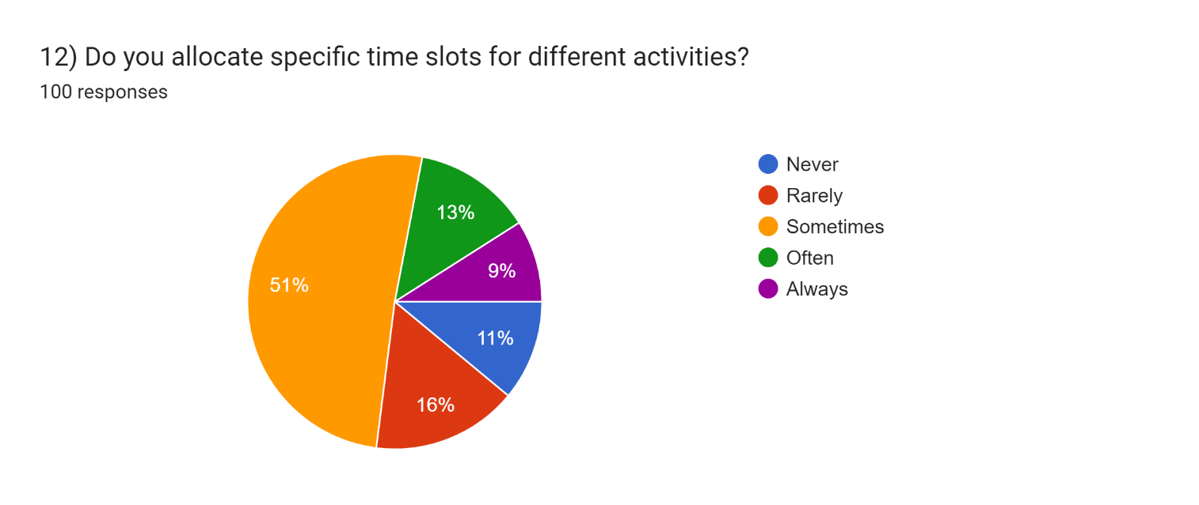

Participants in the SLIIT time management survey had varying methods for designating periods for different tasks. According to the pie chart, 51% of respondents said they sometimes set out certain periods for various hobbies. This implies that a sizable proportion of students periodically plan their calendars by designating time for certain chores and obligations.

Furthermore, 16% of participants reported rarely designating time slots for tasks, showing that this type of time management strategy is less common in this group. However, 13% of respondents acknowledged designating time slots, whilst 11% claimed to never do so. Furthermore, 9% of participants reported always scheduling periods for certain tasks. Overall, the pie chart depicts SLIIT students' various methods of time allocation, covering occasional to ongoing scheduling techniques.

**5.3 Do you intentionally schedule breaks during your day.**

Forms response chart. Question title: 16) Do you intentionally schedule breaks during your day?
. Number of responses: 100 responses.

Participants in the SLIIT time management survey had different behaviors when it came to taking purposeful breaks during the day. According to the pie chart, the majority of respondents (42%), reported that they occasionally arrange breaks during the day. This shows that a considerable proportion of students appreciate the value of taking pauses to recharge and stay productive.

Furthermore, 25% of participants said they rarely scheduled breaks, indicating that this group takes less purposeful breaks than others. However, 16% of respondents acknowledged regularly arranging breaks, while 9% claimed to never do so. Furthermore, 8% of participants reported always arrange breaks throughout the day. Overall, the pie chart demonstrates a wide range of purposeful break scheduling patterns among SLIIT students, from occasional to constant inclusion of breaks into their daily routines.

**5.4 Do you employ any specific techniques or methods to enhance your time management.**

Forms response chart. Question title: 18) Do you employ any specific techniques or methods to enhance your time management?
. Number of responses: 100 responses.

In the SLIIT time management survey, 69% of participants reported using particular tactics or procedures to improve their time management. This proactive approach shows that many students actively seek techniques to enhance their time management skills. To-do lists, time management applications, task breakdown, SMART objectives, and the Pomodoro Technique are all common ways.   
  
However, it is important to note that the remaining 31% of participants do not use any specific strategies or procedures. This shows that a significant proportion of students may use informal or unplanned approaches to time management, or they may be unaware of or prioritize the implementation of formal time management measures.   
  
Overall, good time management looks different for each person, and although some students actively seek out and execute certain procedures, others may use various approaches or may not see the need for organized methods.

**6 Managing Workload and Flexibility**

**6.1 How many hours per day do you study outside of class**.

Forms response chart. Question title: 7) How many hours per day do you study outside of class?
. Number of responses: 100 responses.

The SLIIT time management survey found that individuals' study habits outside of class differed significantly. According to the pie chart, 47% of participants said they studied for 3-4 hours each day, whereas 45% studied for 0-2 hours. This shows that a high percentage of students devote considerable amounts of time to studying outside of class, with nearly equal numbers studying for shorter periods.   
  
Furthermore, 8% of individuals reported studying for 5 hours or more per day, demonstrating a small but substantial number of students who devote significant time to academic activities outside of class. Overall, the pie chart depicts SLIIT students' different study habits, with varying amounts of time commitment to out-of-class study sessions.

**6.2 How frequently do you find it challenging to balance your workload**.

Forms response chart. Question title: 9) How frequently do you find it challenging to balance your workload?
. Number of responses: 100 responses.

Participants in the SLIIT time management survey reported a variety of experiences managing their workload. According to the pie chart, 43% of participants had difficulty balancing their workload on sometimes. This shows that a sizable proportion of students periodically fail to manage their academic commitments successfully.   
  
Furthermore, 23% of participants stated that they rarely faced obstacles in managing their workload, indicating that this group experienced fewer difficulties. However, 14% of respondents often cited issues, while 13% said it was always difficult to manage their responsibilities. Furthermore, 7% of interviewees reported having never faced challenges in this area.   
  
Overall, the pie chart depicts SLIIT students' different workload management experiences, which range from occasional issues to ongoing struggles with juggling academic commitments.

**6.3 Do you adjust your schedule to accommodate unexpected events.**

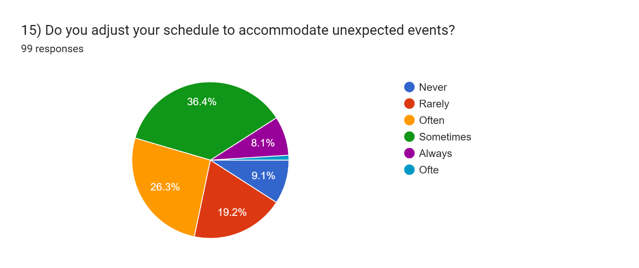

In the survey, individuals' ways of altering their schedules in response to unexpected occurrences were diverse. According to the pie chart, 36.4% of participants said they occasionally changed their schedule to accommodate unexpected circumstances. This shows that a sizable proportion of students periodically change their plans in reaction to unexpected events.   
  
Furthermore, 27.3% of participants reported often modifying their schedules, showing a proactive attitude to dealing with unforeseen circumstances. In contrast, 19.2% of respondents said they rarely made modifications, and 9.1% said they never adjusted their schedules in reaction to unexpected occurrences. Furthermore, 8.1% of interviewees acknowledged constantly adapting to unforeseen occurrences by modifying their plans.   
  
Overall, the pie chart demonstrates the different tactics used by SLIIT students to deal with unexpected situations, with varying degrees of flexibility and adaptation in reaction to unforeseen circumstances.

**7 Handling Distractions and Focus**

**7.1 How frequently do you engage in multitasking.**

The degree of multitasking among participants in the SLIIT time management survey varies. The pie graph shows that 46% of participants said they sometimes multitask. Comparably, 21% said they multitask infrequently, while 17% said they do it frequently. Remarkably, 8% of individuals said they never multitask, while another 8% said they multitask all the time.   
  
These figures show that SLIIT students have varying attitudes toward multitasking; a sizable fraction do it sometimes or on occasion, while others do so more often. This implies a range of preferences and approaches to handling several things at once, which reflects individual variations in time management techniques.

**7.2 How often do you seek advice on time management.**

Participants in the time management study indicated different frequency of advice seeking. According to the pie chart, 29% of respondents often sought time management assistance, while 34% of respondents did so rarely. Furthermore, 22% of respondents said they sometimes sought assistance, indicating a modest degree of participation.   
  
Remarkably, 11% said they never asked for assistance, while 4% said they did regularly. These findings highlight the variety of methods used by participants to look for advice on time management. It emphasizes how crucial it is to respect personal choices and how customized support systems are necessary to successfully meet a range of demands.

Forms response chart. Question title: 17) On a scale of 1 to 5, how confident are you in your time management skills?
. Number of responses: 100 responses.**7.3 On a scale of 1 to 5, how confident are you in your time management skills.**

On a scale from 1 to 5, the column chart shows how confident SLIIT students are in their ability to manage their time. The majority of participants, or 69 people, gave their confidence a level 3 rating, which denotes a moderate degree of certainty in their capacity for time management. Furthermore, fifteen students gave themselves a level 2 rating, indicating some ambiguity or potential for development in their time management abilities. Fewer participants—10 and 6, respectively—rated their time management skills at levels 4 and 5, suggesting higher levels of confidence. Remarkably, none of the participants gave themselves the lowest rating, demonstrating a total lack of self-assurance in their ability to manage their time.

**8 Impact on Academic Performance**

**8.1 To what extent do you believe time management impacts your academic performance.**

The influence of time management on academic success was seen differently by participants in the SLIIT time management survey. The pie chart indicates that 51% of participants thought their academic achievement was somewhat impacted by their ability to manage their time. Comparably, 20% of respondents thought it had a minor effect on their performance, while another 20% thought it had a major impact on their academic results.   
  
It's interesting to note that 6% of participants said their academic performance is greatly impacted by time management, while 3% said it had no effect at all. These comparable numbers across categories point to a wide range of opinions among SLIIT students about the connection between time management and academic achievement. Overall, the findings highlight the significance of appreciating unique viewpoints and the possible impact of time management on academic success.

**9 Effective Strategies for SLIIT Students**

**9.1 What strategies do you believe are most effective in managing time efficiently as a SLIIT Student.**

Students at SLIIT hold a range of beliefs on efficient time management techniques. These include using the time box approach, establishing goals, and minimizing distractions. It's also stressful to finish activities early, stick to a schedule, and take breaks to prevent burnout. Participants stress the need to set daily objectives and deadlines as well as utilize time management applications. They emphasize how important it is to be organized, set priorities, and make schedules for your chores and modules.

It is considered essential to use to-do lists, adhere to deadlines, and revise every day without putting off work. It's also appreciated to use mind mapping techniques, work with a goal, and organize the next day's program every night. Remarkably, a few students discover that living in a boarding home close to SLIIT University helps them manage their time well. All things considered; these techniques show a comprehensive method of time management that is adapted to the requirements of being a SLIIT student.

**10 Conclusion**

To sum up, the information collected from SLIIT students provides important insights into their preferences, attitudes, and time management practices across a range of demographic groups and academic fields. The most engaged students are the younger ones, which highlights how much value they place on time management abilities. Although there aren't many differences between the sexes when it comes to time management activities—male students somewhat outnumber female students—students at SLIIT are generally interested in improving their time management abilities.   
  
With the greatest percentage of students, the Faculty of Computing stands out and suggests that time management is a major priority in this academic field. Furthermore, students exhibit a comprehensive approach to time management by including social influences and convenience in their plans.

Students also show a proactive approach toward planning and organizing, as seen by their preference for goal setting and deadline-setting, and they prioritize assignments according to priority. SLIIT students demonstrate resilience and adaptation in their efficient time management, even in the face of difficulties like multitasking and juggling a heavy workload.   
  
  
Businesses and educators should concentrate on offering resources, tools, and support mechanisms that encourage the development of time management skills to meet the demands of SLIIT students. This includes mentoring programs, workshops, and user-friendly time management tools that are designed to improve students' capacity to establish goals, prioritize chores, and maintain a good work-life balance.

The results essentially highlight the importance of time management for SLIIT students' academic achievement and personal development. A culture of efficient time management may be fostered within the SLIIT community by attending to the requirements and preferences that this study has shown. This will eventually enable students to achieve academic success and beyond.

**11 References**

1. <https://typeset.io/questions/how-does-gender-affect-time-management-and-study-habits-46vvzl891e>
2. <https://qr.ae/pswDIt>

**12 Appendices**

SLIIT students’ attitudes and preferences regarding time management to access the customer feedback form :  
  
[**https://docs.google.com/forms/d/1m9377pN2hwvlsNmOL9Fa8lg4fFrTuqEHI5R5yHWObyg**](https://docs.google.com/forms/d/1m9377pN2hwvlsNmOL9Fa8lg4fFrTuqEHI5R5yHWObyg)